**Comparative analysis of online and offline games with respect to impact and improvement**

**Author: Rakesh Mutnal.P**

**Sandeepa.E**

**Rakesh.R**

Master of Computer Applications

**Email:** rakeshmutnal18@gmail.com

sandeepchari8151@gmail.com

rakeshmr1309@gmail.com

**ABSTRACT**

This study delves into the distinct impacts of online and offline games on players, exploring how each format influences player behaviour, psychological well-being, and social interactions. Online games, with their multiplayer environments and real-time interactions, create unique dynamics that foster community engagement, collaboration, and competition, yet they also introduce challenges such as addiction, social isolation, and exposure to toxic behaviours. In contrast, offline games typically offer solitary, immersive experiences with a strong emphasis on personal achievement and narrative-driven game play. While offline games can provide deep emotional engagement and cognitive benefits, they may also lead to less social interaction, potentially limiting the sense of community and shared experience. The research investigates how these factors contribute to players' cognitive development, emotional responses, and overall gaming experience. By analyzing both positive and negative outcomes, this paper highlights the varying impacts of online and offline games on player motivation, mental health, and social behaviour. The findings offer valuable insights for game designers and researchers seeking to optimize player experience and mitigate the negative effects of gaming.

**INTRODUCTION**

The world of gaming has changed dramatically over the years, giving rise to two primary types of games: online and offline. While both offer unique experiences, they affect players in different ways. This research takes a closer look at how each type of game—online and offline—impacts the people who play them. We’ll dive into how these games shape players' minds, emotions, and social lives, and why understanding these effects is so important for the gaming community and industry.

**Online Games**

Online games are known for their multiplayer environments, where players from all over the world can connect and compete in real-time. These games create vibrant digital communities and offer exciting opportunities for collaboration and competition. They bring people together, sometimes forming strong friendships or even life-long connections. However, they also come with some challenges. The constant interaction and global connectivity can sometimes lead to toxic behavior, addiction, or feelings of stress and anxiety. While online games foster a sense of belonging and excitement, they also come with risks that can impact players' mental health and emotional well-being. Understanding how these factors play out is key to creating healthier, more enjoyable gaming experiences.

**Offline Games**

On the flip side, offline games provide a more personal, solo experience. Without the pressure of interacting with others in real-time, players can dive into deeply immersive stories, puzzles, or challenges at their own pace. These games often offer a sense of achievement and relaxation, as players focus on their own progress and enjoy the experience without distractions. However, while offline games can be great for mental stimulation and personal growth, they can also lead to feelings of isolation, as they tend to limit social interaction. Even though players can get lost in the game world, the lack of a shared experience may sometimes leave them feeling disconnected from others.

**LITERATURE REVIEW**

**Impact of Online Games on Players**

Online games create a virtual world where players interact, compete, and collaborate with others worldwide. According to Cole and Griffiths (2007), online gaming fosters social connections and friendships that transcend geographical boundaries. Multiplayer online games encourage teamwork, strategic thinking, and adaptability. Research by Green and Bavelier (2003) suggests that action-based online games enhance visual-spatial skills and multitasking abilities.

Despite these benefits, online gaming also presents challenges. Kuss and Griffiths (2012) highlight the addictive nature of online games, where players may prioritize gaming over personal and professional responsibilities. The anonymity of online platforms can contribute to toxic behaviour, such as cyber bullying and harassment (Linderoth, 2012). Furthermore, excessive screen time associated with online gaming may lead to physical health issues, including eye strain and sleep disturbances (American Academy of Paediatrics, 2016).

**Impact of Offline Games on Players**

Offline games provide a solitary, immersive experience, allowing players to progress at their own pace. Przybylski and Ryan (2009) emphasize that offline gaming promotes intrinsic motivation, where players derive satisfaction from personal achievements rather than external rewards. Offline games also enhance cognitive functions such as problem-solving and critical thinking (Anderson & Dill, 2000).

Emotionally, offline games offer an escape from daily stress, providing relaxation and reducing anxiety (Russoniello, O'Connor, & Parks, 2009). However, they may also contribute to social isolation, as players engage in solitary gaming experiences rather than interacting with others (Granic et al., 2014). While offline games support personal growth, they may lack the sense of community that online gaming provides.

**Comparative Analysis of Online and Offline Games**

Research comparing online and offline gaming highlights key differences. Vorderer et al. (2003) argue that online games provide more opportunities for socialization, while offline games offer a more controlled, focused experience. Griffiths (2017) suggests that online gaming fosters teamwork and competition, whereas offline gaming promotes introspection and individual problem-solving.

An emerging trend is the rise of hybrid games, which integrate online and offline elements. Zeng and Lee (2019) propose that these games combine the best aspects of both formats, allowing players to engage in solo play while also participating in multiplayer experiences. Titles like The Elder Scrolls Online exemplify this hybrid approach, balancing immersive storytelling with social interaction

**RESEARCH GAP / RESEARCH PROBLEM STATEMENT**

Although extensive research has explored the effects of gaming, most studies focus exclusively on either online or offline games. There is limited comparative research examining how both formats influence cognitive, emotional, and social aspects of gaming behavior. Additionally, existing research often overlooks the hybrid gaming model, which blends online and offline elements. This study aims to fill these gaps by providing a comprehensive analysis of how gaming formats shape player experiences and well-being.

**RESEARCH OBJECTIVE/RESEARCH HYPOTHESIS**

**Research Objectives:**

* To analyze the impact of online gaming on cognitive skills, emotional responses, and social interactions.
* To examine how offline gaming influences cognitive engagement, relaxation, and social connectivity.
* To compare the benefits and drawbacks of online and offline gaming formats.
* To explore the implications of hybrid gaming models on player well-being.

**Research Hypotheses:**

Online gaming positively influences teamwork, strategic thinking, and social connectivity.

* Online gaming increases the risk of addiction and exposure to toxic behaviour.
* Offline gaming enhances cognitive problem-solving skills and emotional relaxation.
* Offline gaming may contribute to social isolation due to its solitary nature.

**RESEARCH METHODOLOGY**

**Online Games**

This section outlines the research methods and approaches used to analyze the impact of different video game categories on players. The study employs a qualitative and quantitative approach, utilizing data from literature reviews, surveys, and case studies to examine the positive and negative effects of gaming. A classification framework is established based on five primary game categories: **Action & Shooter Games, Adventure & Exploration, Casual & Puzzle Games, Multiplayer & Strategy, and Sports & Racing Games**. Each category is evaluated for its cognitive, social, and psychological effects. The research also considers factors such as game type (online vs. offline), player demographics, and behavioral patterns to provide a comprehensive understanding of gaming’s influence.

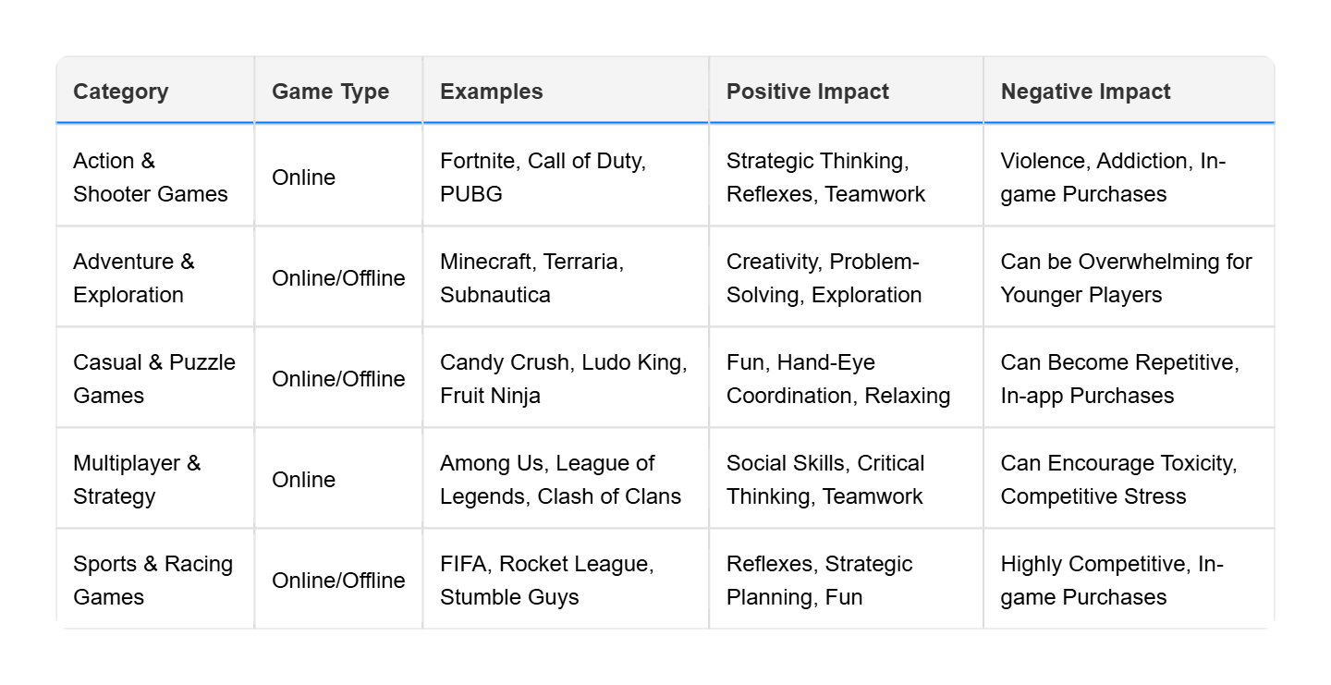

**Offline Games**

This research aims to analyze the impact of traditional outdoor games on physical, cognitive, and social development. The study employs a mixed-methods approach, combining qualitative analysis of historical and cultural significance with quantitative data collected from participants engaging in these games.

The methodology consists of three key phases:

1. **Game Selection and Classification** – A diverse range of traditional outdoor games was identified and categorized based on required resources, time commitment, number of players, and gameplay mechanics.
2. **Impact Assessment** – The positive and negative effects of each game were examined in terms of physical fitness, strategic thinking, teamwork, coordination, and potential risks of injury.
3. **Data Collection** – Observational studies, surveys, and interviews with players and experts were conducted to measure the effectiveness of these games in improving various skills and overall well-being.



**COMPARATIVE ANALYSIS OF DIFFERENT GAME CATEGORIES OF ONLINE GAMES**

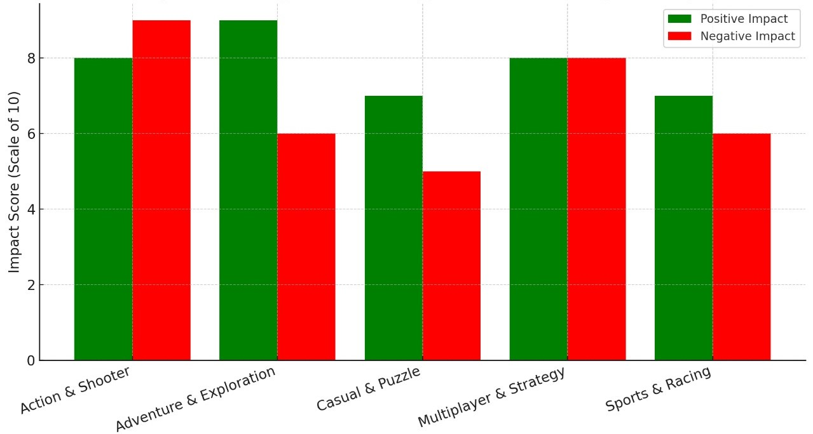

**Fig: 1.0**

**COMPARATIVE ANALYSIS OF DIFFERENT GAME CATEGORIES OF OFFLINE GAMES**

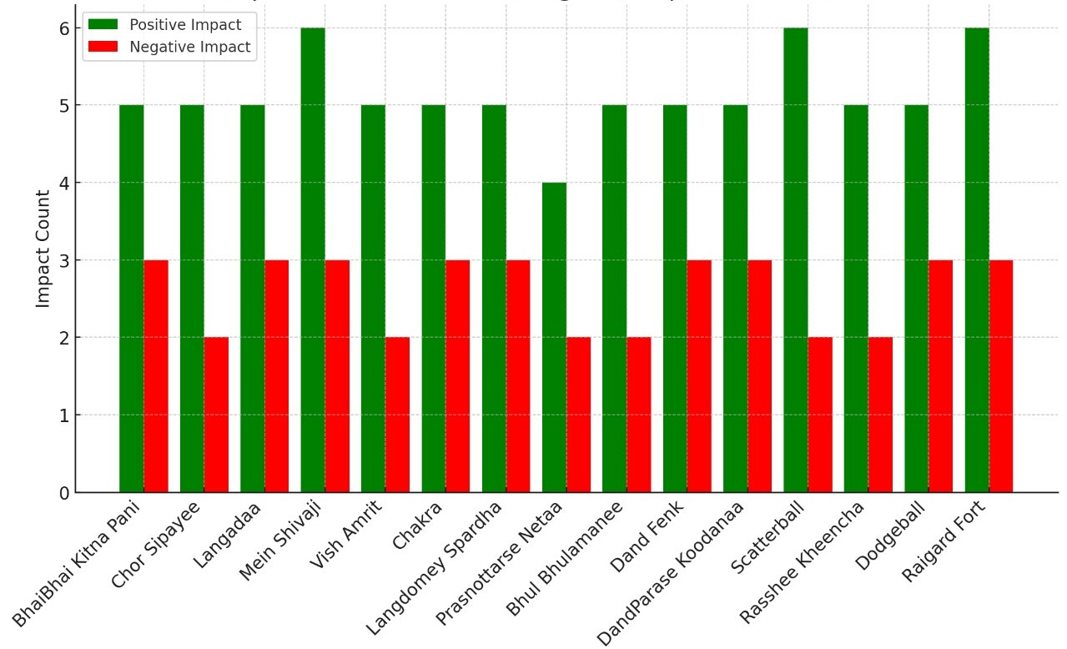

**Fig: 2.0**

**RESULT AND DISCUSSION:** The Impact of Online and Offline Games

Gaming, whether online or offline, affects players in different ways—shaping their social lives, cognitive skills, emotional well-being, and even physical health. Here’s a breakdown of the key findings in a more digestible way:

**Social Connection: Online vs. Offline Games**

Online games bring people together. Whether it’s teaming up in *Fortnite* or strategizing in *League of Legends*, these games create a sense of community. Players build friendships across the globe, working together and competing in real time (Cole & Griffiths, 2007). This social engagement can be a major plus, giving players a sense of belonging. Offline games, on the other hand, are more of a solo experience. Players enjoy rich, immersive stories at their own pace. This can be rewarding, but it may also lead to isolation if gaming replaces real-world interactions (Granic et al., 2014).

**Brainpower and Skill Development**

Both online and offline games challenge the brain but in different ways. Online games demand quick thinking, teamwork, and fast reflexes. Research shows that action-based online games improve reaction times, multitasking, and visual-spatial skills (Green & Bavelier, 2003).Offline games lean more toward strategic thinking and problem-solving. Strategy and puzzle games help players develop patience, logical reasoning, and deep concentration (Anderson & Dill, 2000). Unlike fast-paced online games, offline games give players the freedom to think through challenges at their own speed.

**Mental Well-being: The Good and the Bad**

Gaming can be a great way to relax, but it also comes with risks. Online games, while socially engaging, can lead to addiction. Some players struggle to step away, especially in games designed with endless progression (Kuss & Griffiths, 2012). Toxic behavior in online communities—such as cyber bullying—can also take a toll on mental health (Linderoth, 2012).Offline games offer a different kind of escape. They can be calming, helping players unwind without the stress of competition (Russoniello et al., 2009). However, if played excessively, they can lead to social withdrawal, as they don’t provide the same community experience as online games.

**Physical Health: Screen Time and Sedentary Lifestyles**

Both types of games share one major downside—too much sitting. Whether playing online or offline, long gaming sessions can cause issues like eye strain, bad posture, and even sleep problems (American Academy of Pediatrics, 2016). Because gaming is so immersive, many players struggle to take breaks, leading to physical health concerns.

**Final Thoughts: Finding Balance**

Both online and offline games have their strengths and weaknesses. Online games provide social interaction, teamwork, and fast decision-making but can also lead to addiction and stress. Offline games encourage problem-solving and relaxation but can sometimes be isolating. The key takeaway? Moderation is everything. Balancing gaming with other activities—like exercise and face-to-face interactions—can help players enjoy the best of both worlds without the downsides.

**CONCLUSION**

This study highlights the distinct impacts of online and offline games on players. While online games excel in fostering social connections and skill development, they also present challenges related to mental health and toxic behaviour. Offline games provide immersive, stress-relieving experiences but may lead to social withdrawal if played excessively. As gaming continues to evolve, hybrid models may offer a balanced approach, combining the strengths of both formats. Future research should explore long-term player engagement with hybrid games and the potential psychological effects of this blended gaming experience.

**FUTURE SCOPE**

Gaming is evolving rapidly, and its impact on players—both positive and negative—continues to change. As technology advances, future research can dive deeper into several important areas to better understand and improve the gaming experience.

#### ****1. The Rise of AI and Virtual Reality (VR) in Gaming****

With AI-driven game mechanics and immersive VR worlds becoming more common, how will these technologies shape player behavior and cognitive development?

#### ****2. Gaming as a Tool for Mental Health and Education****

There’s growing interest in using games beyond entertainment. Could certain games be designed to improve mental health by reducing stress and anxiety? Can educational games make learning more engaging and effective? Future research could look into how gaming can be harnessed to benefit cognitive and emotional well-being while minimizing risks like addiction.

#### ****3. Physical Health and Gaming Ergonomics****

With long hours of gaming linked to health issues like eye strain, posture problems, and sleep disturbances, more research is needed to develop solutions. Could adaptive gaming setups or new game mechanics encourage healthier habits, like movement-based play? Future research could explore how to make gaming more physically engaging without compromising the experience.

**REFERENCES**

**Online Games:**

**1. Psychological Effects of MMORPGs**

* *Summary:* This article discusses the psychological effects of Massively Multiplayer Online Role-Playing Games (MMORPGs), including aspects like identity exploration and social interactions.
* *Reference:* [en.wikipedia.org](https://en.wikipedia.org/wiki/Massively_multiplayer_online_role-playing_game?utm_source=chatgpt.com)

**2. Online Gaming and Gambling Risks**

* *Summary:* This article highlights the risks associated with in-game purchases in online games, which can lead to gambling addictions among players.
* *Reference:* [theguardian.com](https://www.theguardian.com/australia-news/article/2024/sep/01/australia-online-gaming-new-laws-gambling-loot-boxes-children?utm_source=chatgpt.com)

**Offline Games:**

# 1. Khel / Games

* *Summary:* A study found that playing offline games stimulate in improving players moods, suggesting potential mental health benefits.
* *Reference:* https://karyakartablog.files.wordpress.com/2017/07/khel_book.pdf

**2. Offline Play and Child Development**

* *Summary:* This article examines the decline in unstructured outdoor play among children and its impact on motor skills and social development.
* *Reference:* [vox.com](https://www.vox.com/family/370880/play-kids-outdoor-screen-time-phone-ipad-games?utm_source=chatgpt.com)